**Lab 2.1.1 Essentials of if-else statement**

**Code:**

#include <iostream>

using namespace std;

int main()

{

int year;

cout << "Enter a year: ";

cin >> year;

if (year % 4 != 0)

cout << "This is common year" << endl;

else if (year % 100 != 0)

cout << "This is leap year" << endl;

else if (year % 400 != 0)

cout << "This is common year" << endl;

else

cout << "This is leap year" << endl;

return 0;

}

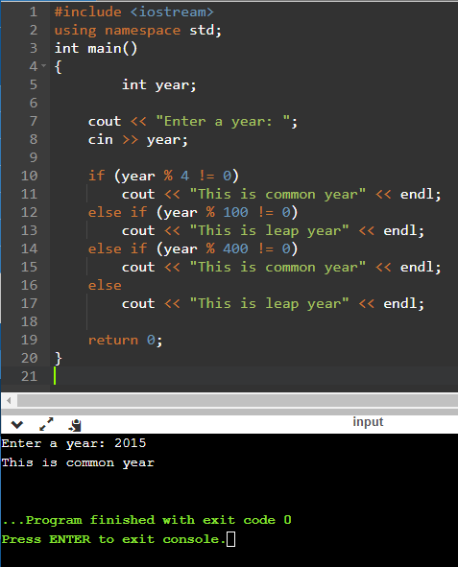

**Lab 2.1.2 Some actual evaluations – taxes**

**Code:**

#include <iostream>

using namespace std;

int main()

{

float grossprice, taxrate, netprice, taxvalue;

cout << "Enter a gross price: ";

cin >> grossprice;

cout << "Enter a tax rate: ";

cin >> taxrate;

netprice = grossprice / (1 + (taxrate / 100));

taxvalue = netprice * (taxrate / 100);

cout << "Net price: " << netprice << endl;

cout << "Tax value: " << taxvalue << endl;

return 0;

}

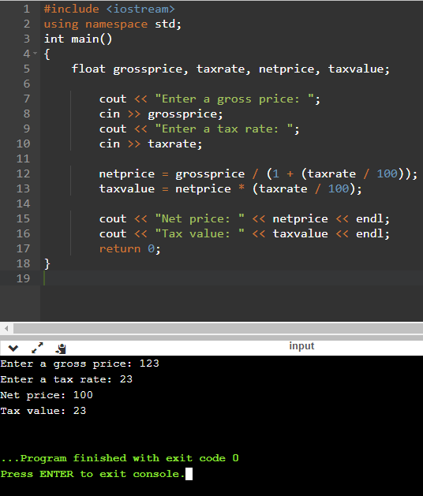

**Lab 2.1.3 Some actual evaluations - converting measurement systems**

**Code:**

#include <iostream>

using namespace std;

int main()

{

int sys;

double m, ft, in;

cout << "Choose your measuring system (1 for imperial and 0 for metric): ";

cin >> sys;

if (sys == 1) // imperial

{

cin >> in;

m = in / 3.28084;

cout << "Your result: " << m << " m" << endl;

}

if (sys == 0) // metric

{

cin >> in;

ft = in * 3.28084;

cout << "Your result: " << ft << " ft" << endl;

}

return 0;

}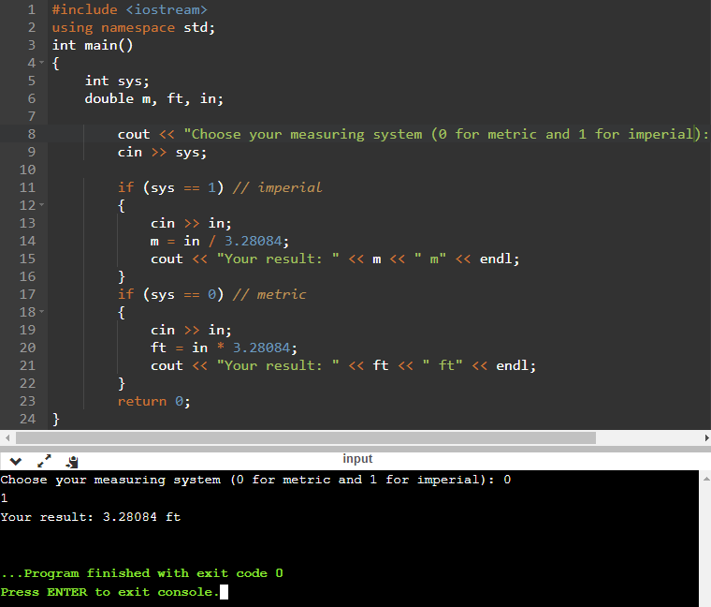

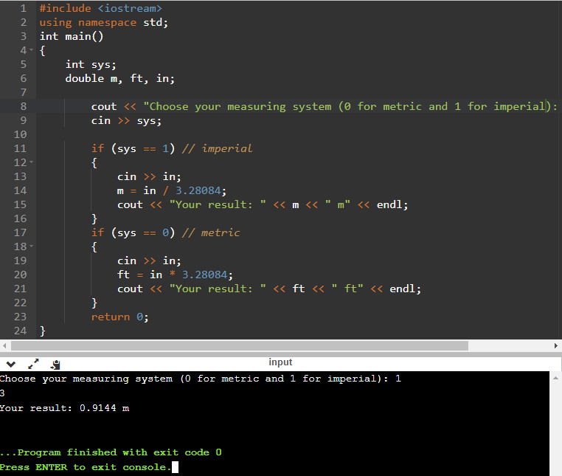

**Lab 2.1.4 Some actual evaluations - finding day of week**

**Code:**

#include <iostream>

using namespace std;

int main()

{

int month, day, answer, year;

cout << "Enter the date (year, mounth, day): ";

cin >> year;

cin >> month;

cin >> day;

if (month <= 12 && month > 0 && year >= 1900 && year < 2100)

{

month -= 2;

if (month < 0)

{

month += 12;

year -= 1;

}

month = (month * 83) / 32;

month += day;

month += year;

month += year / 4;

month -= year / 100;

month += year / 400;

answer = month % 7;

if (answer == 0)

cout << "That day is Sunday" << endl;

if (answer == 1)

cout << "That day is Monday" << endl;

if (answer == 2)

cout << "That day is Tuesday" << endl;

if (answer == 3)

cout << "That day is Wednesday" << endl;

if (answer == 4)

cout << "That day is Thursday" << endl;

if (answer == 5)

cout << "That day is Friday" << endl;

if (answer == 6)

cout << "That day is Suttarday" << endl;

if (answer < 0 || answer > 6)

cout << "Error: " << answer << endl;

}

else

cout << "Incorrect!" << endl;

return 0;

}

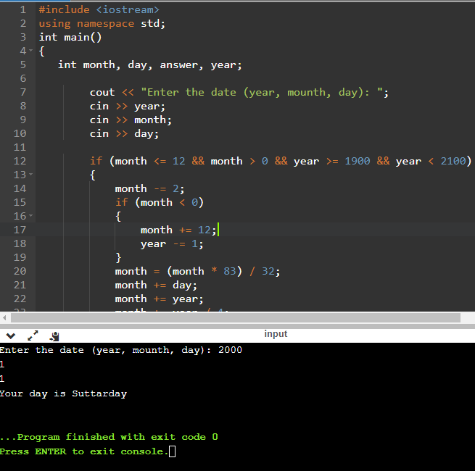

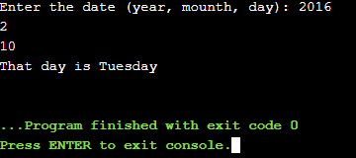

**Lab 2.1.5 Some actual evaluations - finding date of Easter**

Code:

#include <iostream>

using namespace std;

int main()

{

int a, b, c, d, e, year;

cout << "Enter year`s number: ";

cin >> year;

a = year % 19;

b = year % 4;

c = year % 7;

d = (a * 19 + 24) % 30;

e = ((2 * b) + (4 * c) + (6 * d) + 5) % 7;

cout << "Value = " << d + e << endl;

if (e + d < 10)

cout << "Easter falls on the March " << d + e + 22 << endl;

else

cout << "Easter falls on the April " << d + e - 9 << endl;

return 0;

}

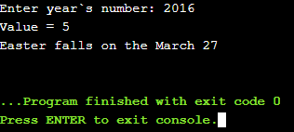

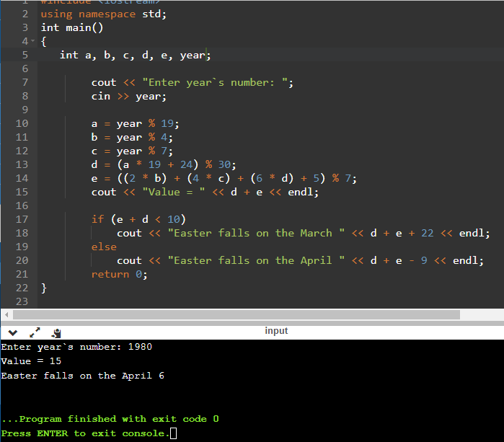

**Lab 2.3.1 Collatz's hypothesis**

**Code:**

#include <iostream>

using namespace std;

int main()

{

int c0, c = 0;

cout << "Enter the number: ";

cin >> c0;

while (c0 != 1)

if (c0 > 0 && c0 != 1)

if (c0 % 2 == 0)

{

c++;

c0 = c0 / 2;

cout << c0 << endl;

}

else

{

c++;

c0 = 3 * c0 + 1;

cout << c0 << endl;

}

else

cout << "Error" << endl;

cout << "Steps = " << c << endl;

return 0;

**}**

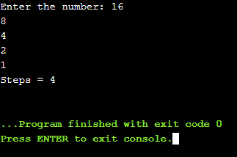

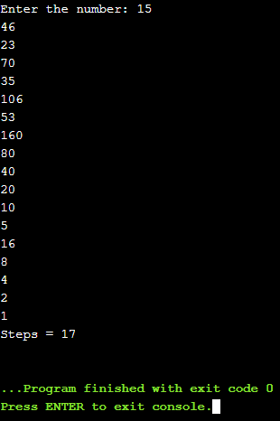

**Lab 2.3.2 Some actual evaluations – finding the value of π**

Code:

#include <iostream>

#include<cmath>

using namespace std;

int main()

{

long n;

cout << "number of interactions: ";

cin >> n;

double *a = new double[n];

double Pi = 0.;

for (int i = 0; i < n; i++)

a[i] = pow(-1, i) / (2 * i + 1);

for (int i = 0; i < n; i++)

Pi += 4 * a[i];

cout.precision(20);

cout << "Pi = " << Pi<< endl;

return 0;

}

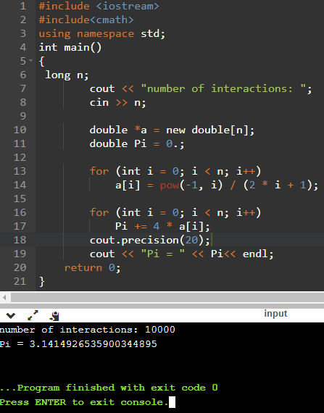

**Lab 2.3.3 Finding positive powers of 2**

Code:

#include <iostream>

#include<cmath>

using namespace std;

int main()

{

long int n, n1 = 1;

cout << "Enter a number: ";

cin >> n;

for (int i = 0; i < n; i++)

n1 = n1 * 2;

cout << "Result: " << n1 << endl;

return 0;

}

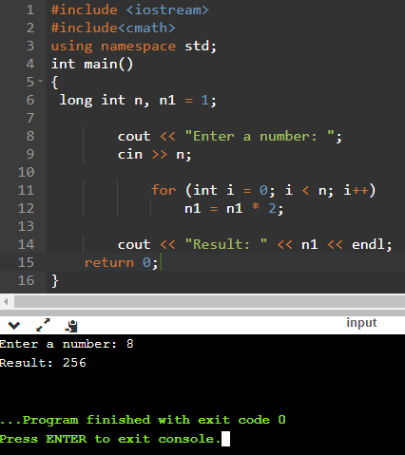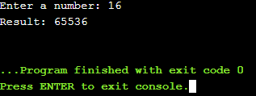

**Lab 2.3.4 Finding negative powers of 2**

Code:

#include <iostream>

#include<cmath>

using namespace std;

int main()

{

int n;

double nn = 1;

cout << "Enter a number: ";

cin >> n;

for (int i = 0; i < n; i++)

nn /= 2;

cout.precision(20);

cout << "Result: " << nn << endl;

return 0;

}

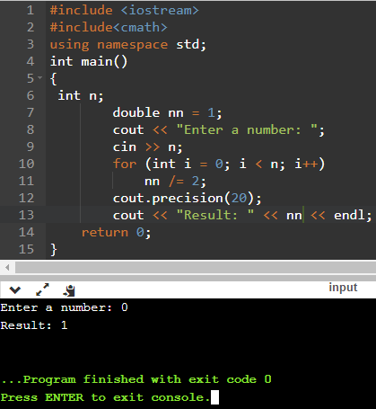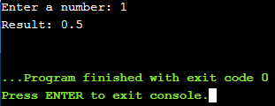

**Lab 2.3.5 Drawing squares (actually: rectangles)**

**Code:**

#include <iostream>

using namespace std;

int main()

{

int n;

cout << "Enter the square size: ";

cin >> n;

if (n > 1 && n < 100)

{

cout << '+';

for (int i = 0; i < n; i++)

cout << '-';

cout << '+' << endl;

for (int i = 0; i < n; i++)

{

cout << '|';

for (int j = 0; j < n; j++)

cout << ' ';

cout << '|' << endl;

}

cout << '+';

for (int i = 0; i < n; i++)

cout << '-';

cout << '+' << endl;

}

else

cout << "Error" << endl;

return 0;

}

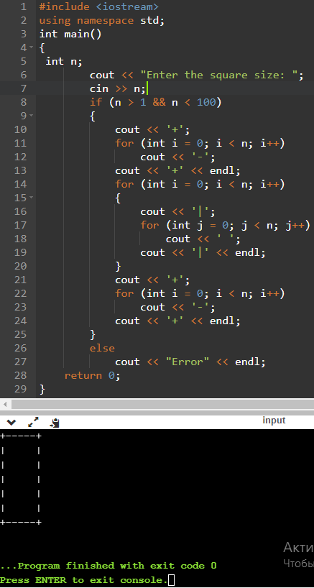

**Lab 2.3.6 Postcard from Gizah**

Code:

#include <iostream>

#include<cmath>

using namespace std;

int main()

{

int k;

cout << "Enter the size:";

cin >> k;

if (k >= 2 && k <= 9)

{

for (int i = 0; i < k - (k / 10); i++)

cout << ' ';

cout << "*";

cout << endl;

for (int j = 0; j < k - 2; j++)

{

for (int i = 1; i < k - j; i++)

cout << ' ';

cout << '*';

for (int x = k - 2 * j; x <= k; x++)

cout << ' ';

cout << '*';

cout << endl;

}

double a;

a = k * 1.6;

if (k > 2 && k < 6)

a += 1;

if (k > 5 && k < 8)

a += 2;

if (k > 7 && k <= 9)

a += 3;

cout << " ";

for (int j = 0; j < a; j++)

cout << "*";

cout << endl;

}

else

cout << "Error! Inappropriate input!";

cout << endl;

return 0;

}

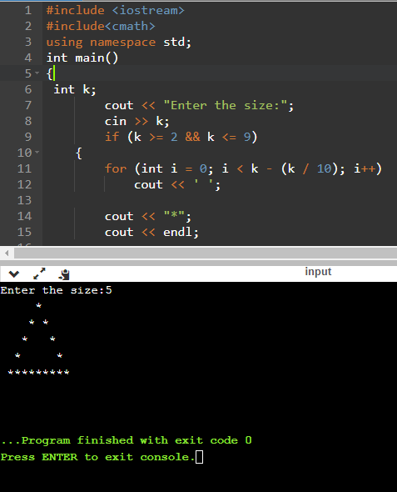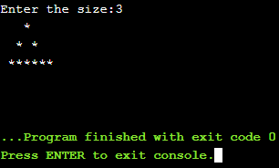

**Lab 2.3.7 Do it yourself: Fibonacci sequence**

Code:

long int Fib(int i)

{

if (i < 1)

return 0;

if (i <= 2)

return 1;

if (i == 3)

return 2;

return Fib(i - 1) + Fib(i - 2);

}

#include <iostream>

#include<cmath>

using namespace std;

int main()

{

int i = 0, n, index = -1;

cout << "Choose a number: ";

cin >> n;

if (n < 56 && n > 0)

{

for (int i = 0; i < 56; ++i)

{

index++;

if (index == n)

cout << Fib(i) << endl;

}

}

else

cout << "Error" << endl;

return 0;

}

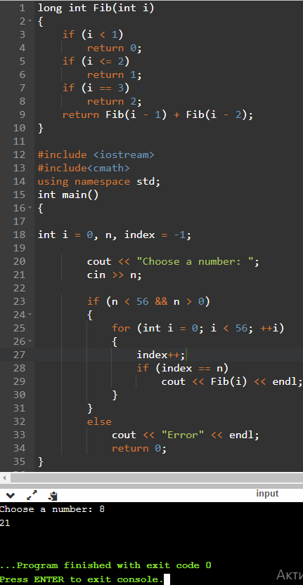

**Lab 2.3.8 Do it yourself: factorials**

Code:

#include <iostream>

#include<cmath>

using namespace std;

int main()

{

int f, factorial = 1;

cout << "Enter a number: ";

cin >> f;

for (int i = 1; i <= f; i++)

factorial *= i;

cout << "Number`s factorial = " << factorial << endl;

return 0;

}

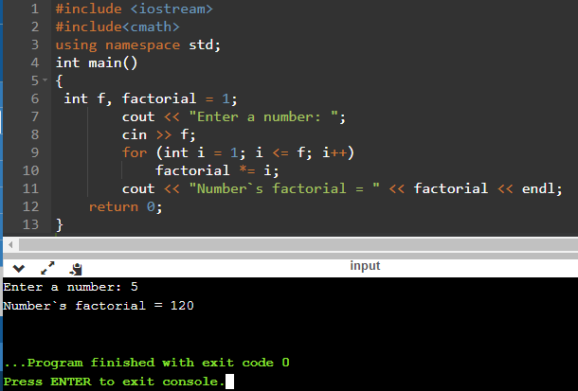

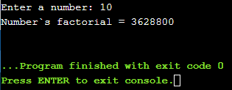

**Lab 2.3.9 The riddle (a bit of a tricky one)**

Code

#include <iostream>

#include<cmath>

using namespace std;

int main()

{

float x, y;

cout << "Enter x: ";

cin >> x;

y = (x - 1) * (x - 1) + 1;

cout << "Result: " << y << endl;

return 0;

}

